CHN Intranet website https://webconnect.sfdph.org/sfccc-duo
What you need to log in?
- Active Directory – First and Last Name
- DUO Authentication Method (smartphone, mobile phone or landline phone)
- CHN or LCR Log in
Contact SFCCC for help with creating accounts. itsupport@sfccc.org

Contents
PRDOC: Invision Provider Database 2
General patient chart navigation: 3
Patient Demographics: 3
Patient outpatient overview function: 4
Appointments: 5
Notes 8
Diagnostics: 9
Medications and allergies, Enterprise med list: 10
CCMS under e-Links 12
Panel management 13
Instructions for Accessing LCR Discharge Worklist 14
Post discharge List Serve: 16
Other Email Notifications: 17
Getting Support: 17

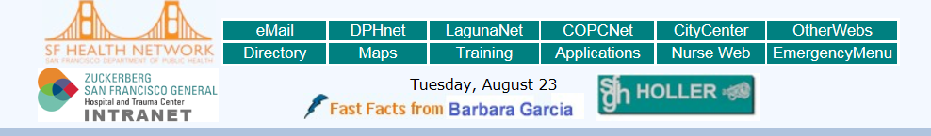
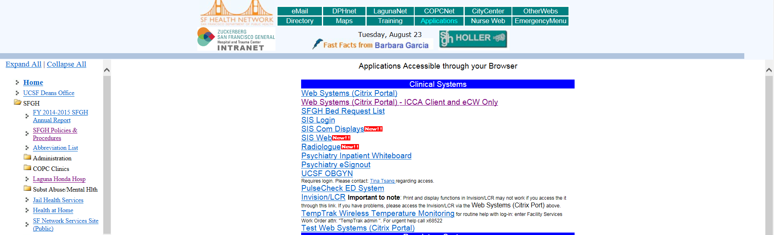
Click on Invision/LCR and log in using your CHN # /LCR log in

PRDOC: Invision Provider Database
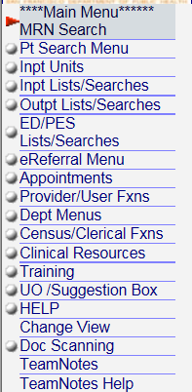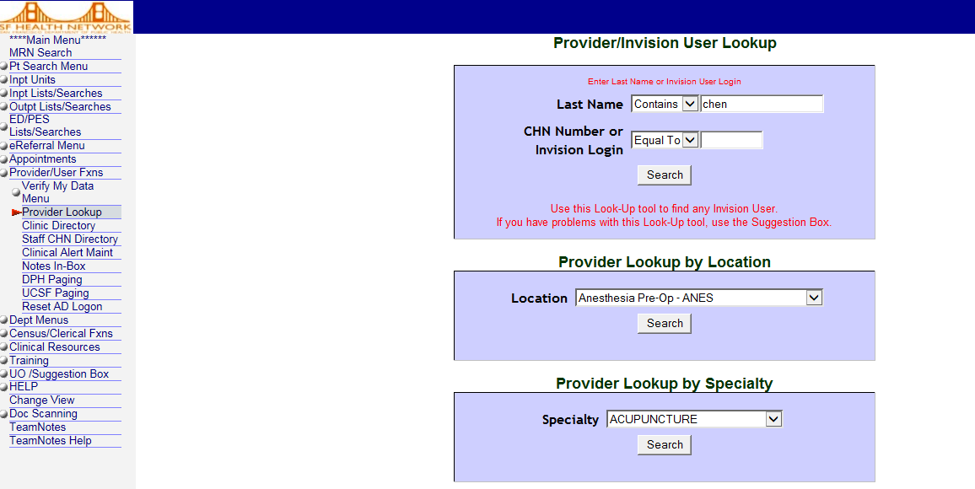
Why is this relevant?
***Important for Care Coordination. ALL communications get sent to provided contact information.
Click Provider Lookup then type name or CHN # or LCR log in.
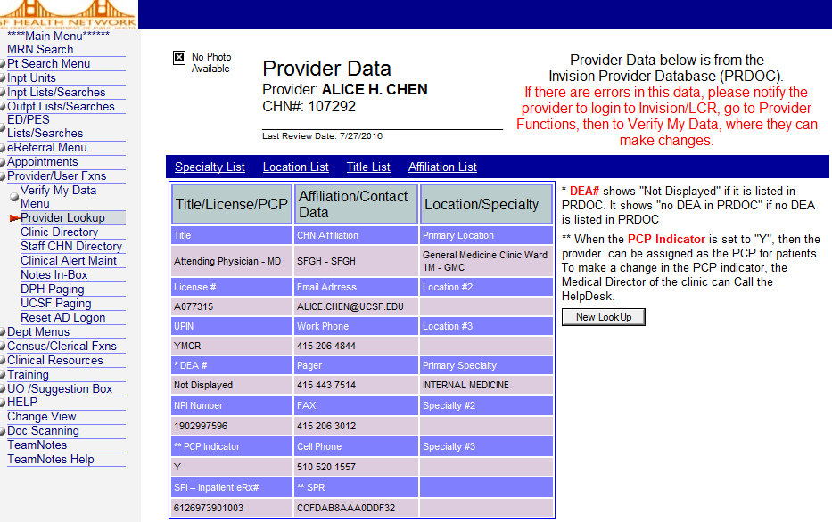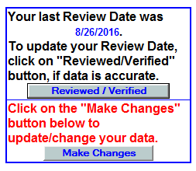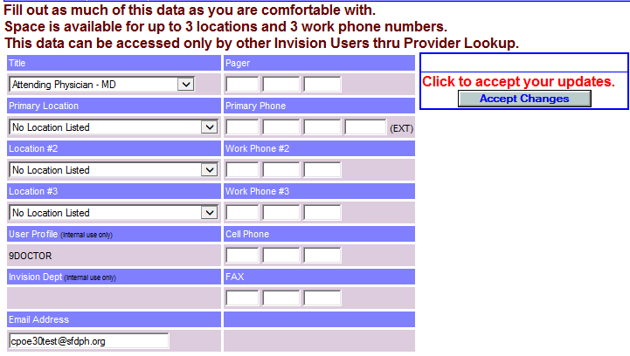

Providers: Enter and update your contact information by clicking on verify my data make changes input changes accept changes once your are done

General patient chart navigation:

Patient Demographics:
Patient PCP/PCC field:
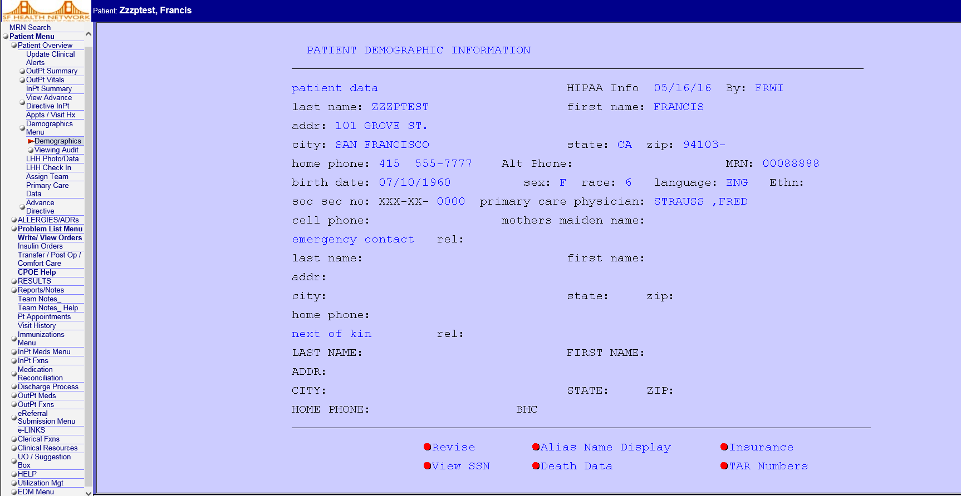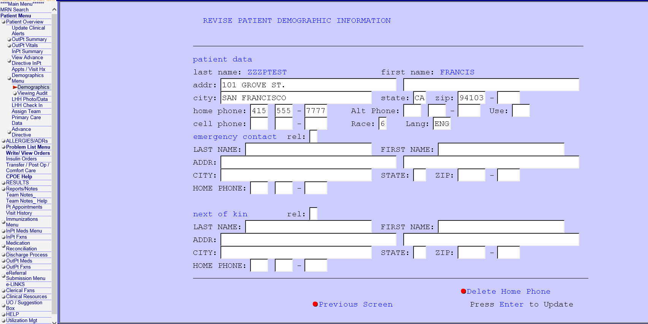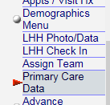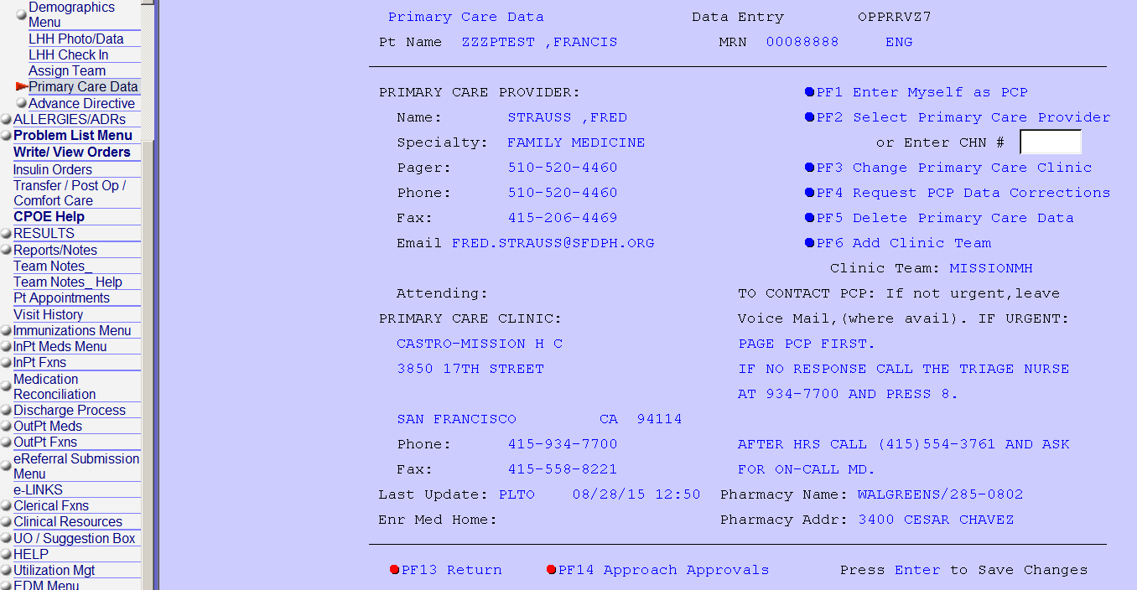
*Please keep patient information updated
*** Important for Primary team to keep information up to date.***
Tool for Treatment Team

- Edit PCP, Primary Care Clinic
- Provider/Clinic: enables other Providers to contact PCP whenever there is a change in their patient’s condition. Important for Specialty Clinics and Diagnostics to relay important results ASAP.
- Clinic staff/Scheduler: enables staff to reach out to patients directly to schedule recommended appointments, send appointment notice or reminders to patient.

Patient outpatient overview function:
Patient overview: Who Uses LCR ? Used primarily by Inpt Service, ED, Clinic specialists
- Update Clinical alert: Helpful tool to enhance patient and staff experience
- Outpt Summary: ONE stop shop view

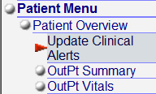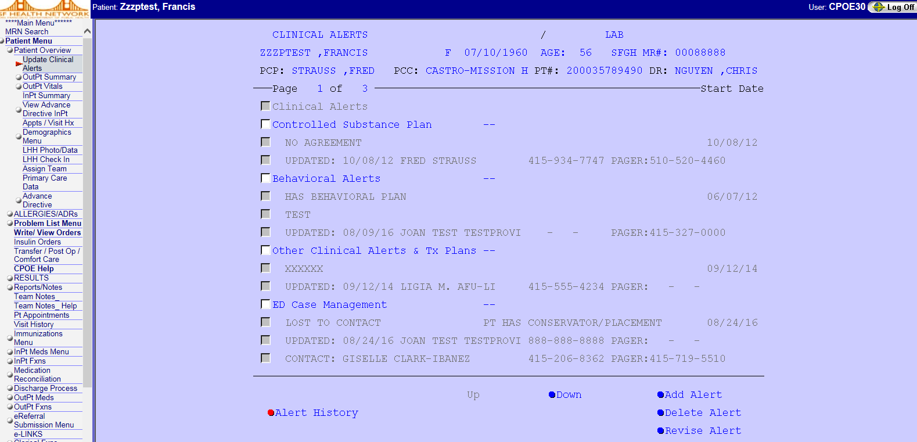
Update Clinical Alerts: Such as Controlled Substance Plan, Behavioral Alert, Case Management and other pertinent information that needs to be communicated to the Treatment team.
1

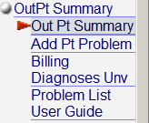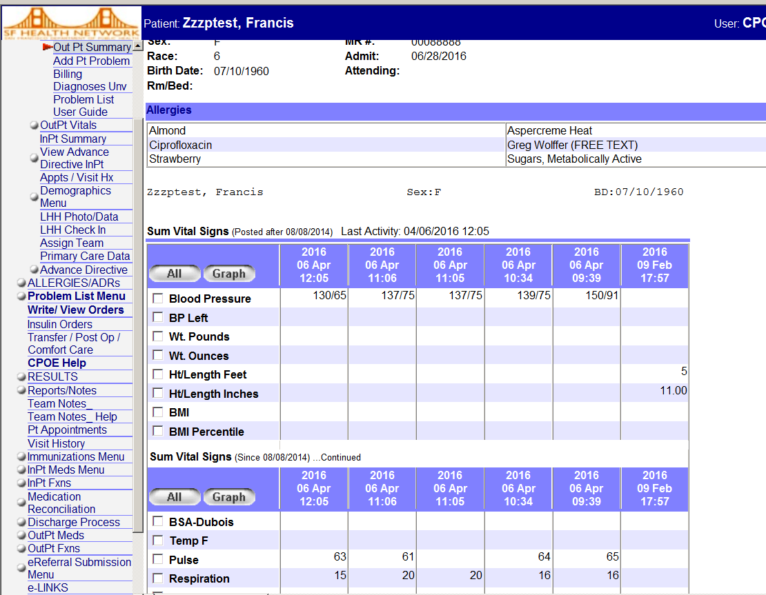
Outpatient summary: This is One Stop Shop navigation for the past 12 months. It includes Allx, VS, Ht/Wt, Lab result, Radiology, Immunization, Reports/notes. Inpatient data including current/active orders while patient is admitted can also be viewed on this page. Results can be viewed as List or Graph

2

Appointments: future, past (visit history only includes attended), no shows (web based view or look in appointments-past), what’s missing OR – this can be accessed by via reports/notes, read progress notes from Surgery Operative Notes
How do you know if your patient has an appointment? Appointment tab - page defaults to Future Appointments. Find all pending appointments for the patient.
FUTURE:
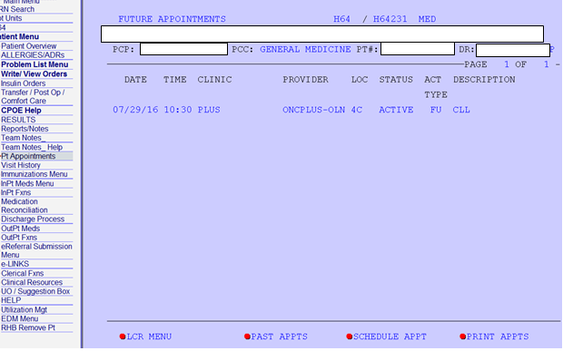

PAST/NO SHOWS:
Where to find past appointment and no shows? There are three (3) ways to look up if patient showed up for appointment (1)Appointment tab-bottom of page PAST APPTS (within current year). (2) Visit History (3) Appts/Visit History

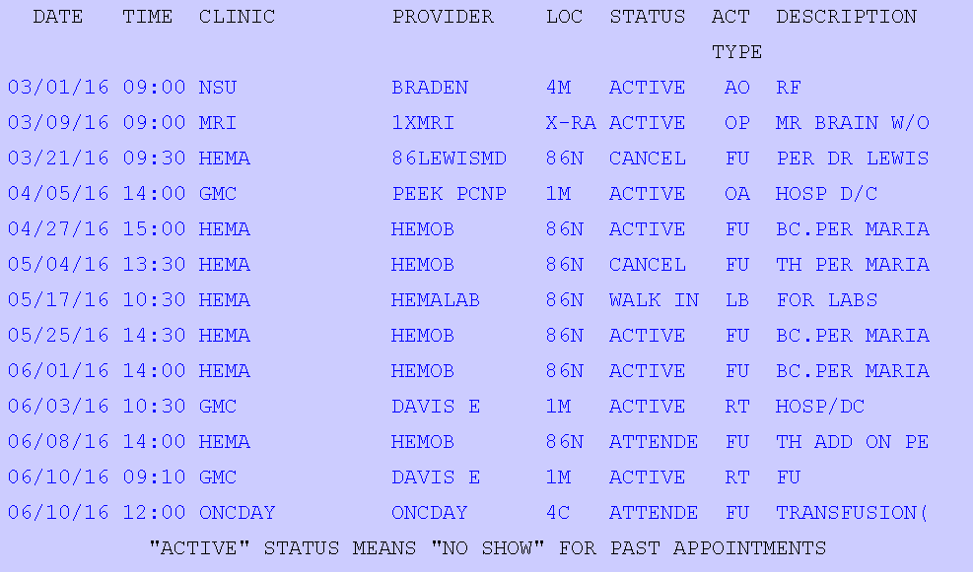
1
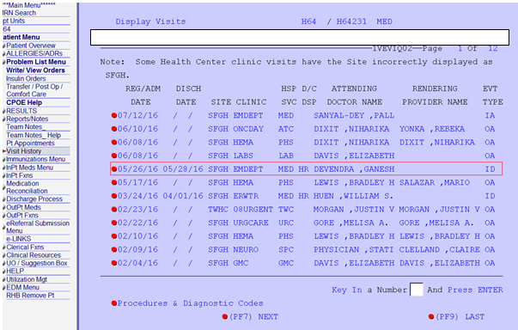
(2) Visit History- goes back >10 years. Helpful when looking up particular eCW progress note, refer to past appointments to find Clinic specific note (eCW is listed under generic heading)
2

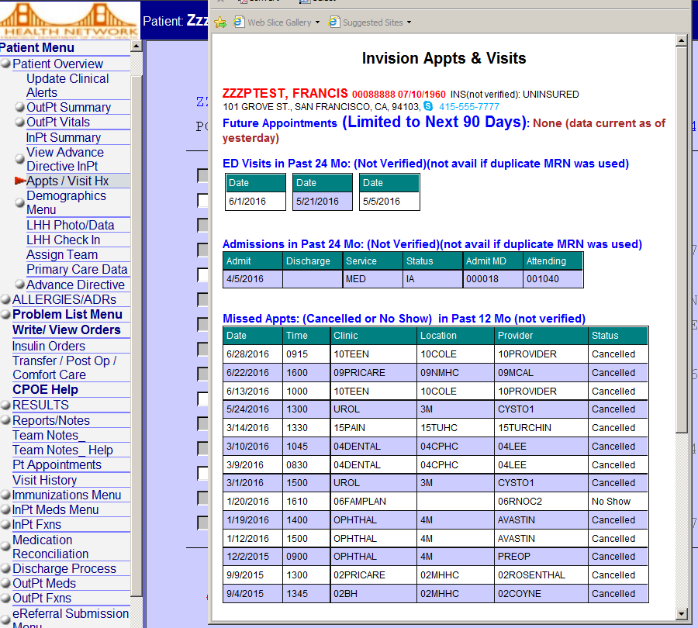
(3) To view patient’s lifetime visit history including previous hospital admission, ED visits, appointments: Proceed to Patient overview- then click on Appts / Visit Hx (convenient but not always complete)

3

Notes:
Click on Reports/Notes to access notes for inpatient, outpatient-under generic entry eCW, does not breakdown by clinic or specialty care, ED (PulseCheck), operative notes (SIS), discharge instructions, discharge medications list.

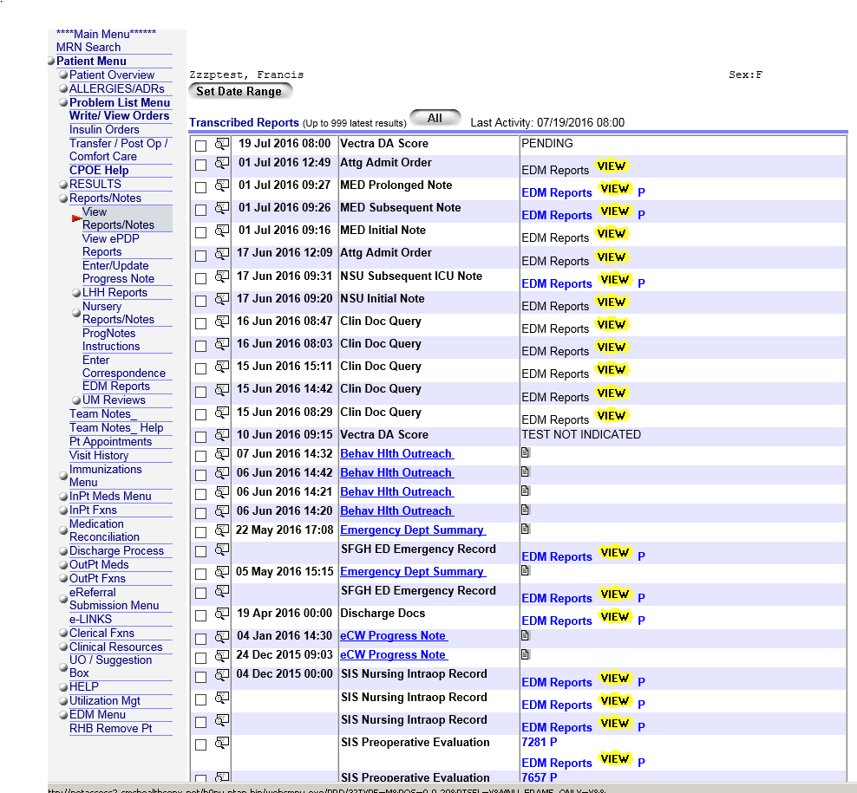
*** eCW notes will be saved and viewed in LCR only when note is locked. May have multiple versions of same note if unlocked for revision after it is sent to LCR. eCW updates every 29 minutes.

Diagnostics: labs results, radiology results, pathology, nuclear medicine, GI procedure etc 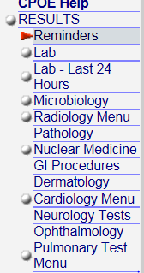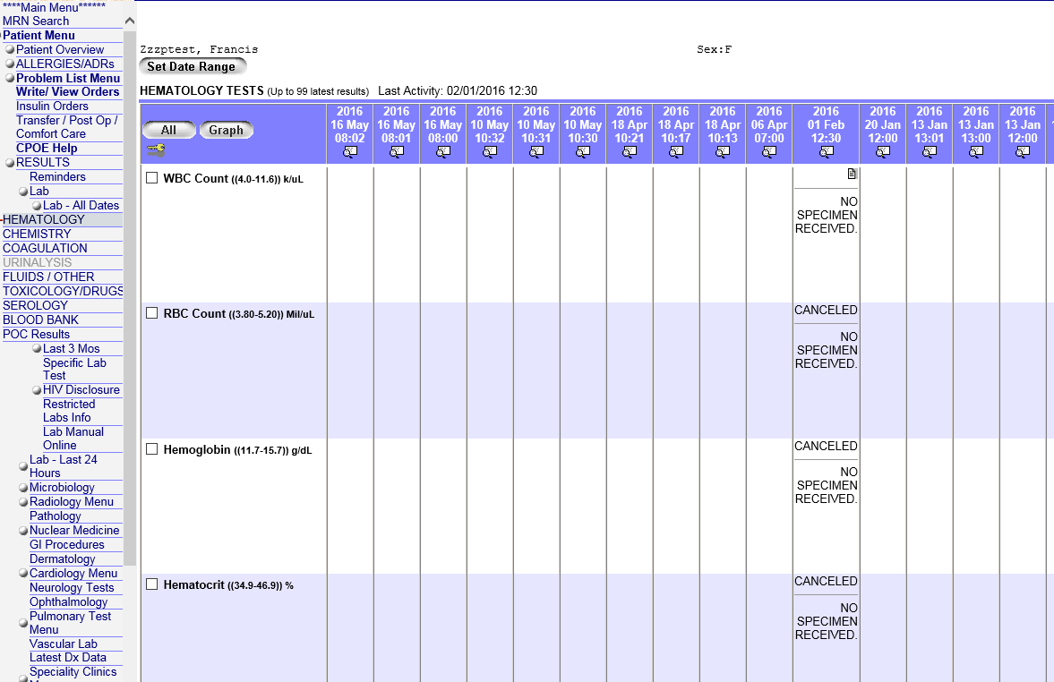
Results tab:
- Labs- general, microbiology.
- Radiology Menu
- Pathology
- Nuclear Medicine
- GI Procedure
- Cardiology Menu
- Neurology
- Pulmonary Test Menu

LAB: General and Microbiology- Lifetime, Last 3 mos. Last 24 hours (list or graph), HIV disclosure, Restricted labs (performed outside),Lab manual Online

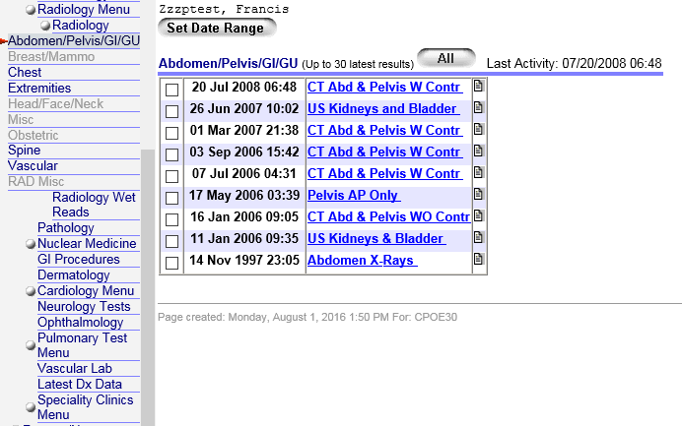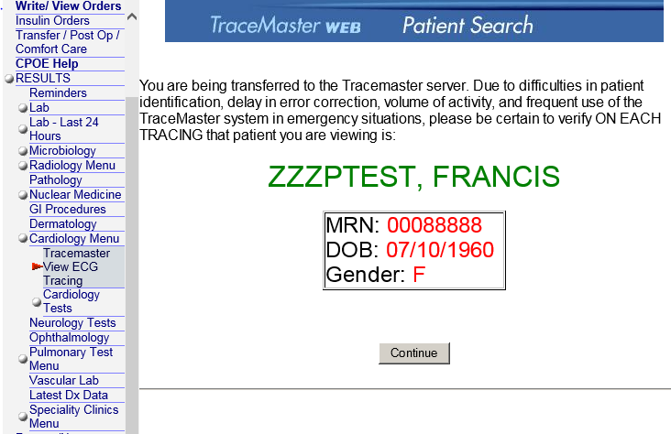
View EKG tracing and other Cardiology Test results, stress test, Echo
Search test results by anatomical location
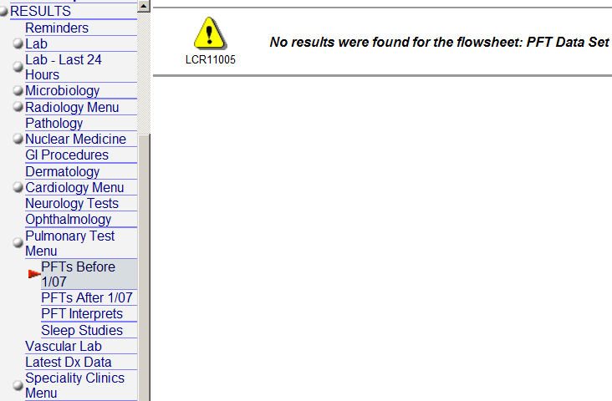
Includes PFT’s, ABG and Sleep study results

Medications and allergies, Enterprise med list:

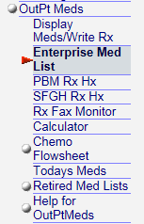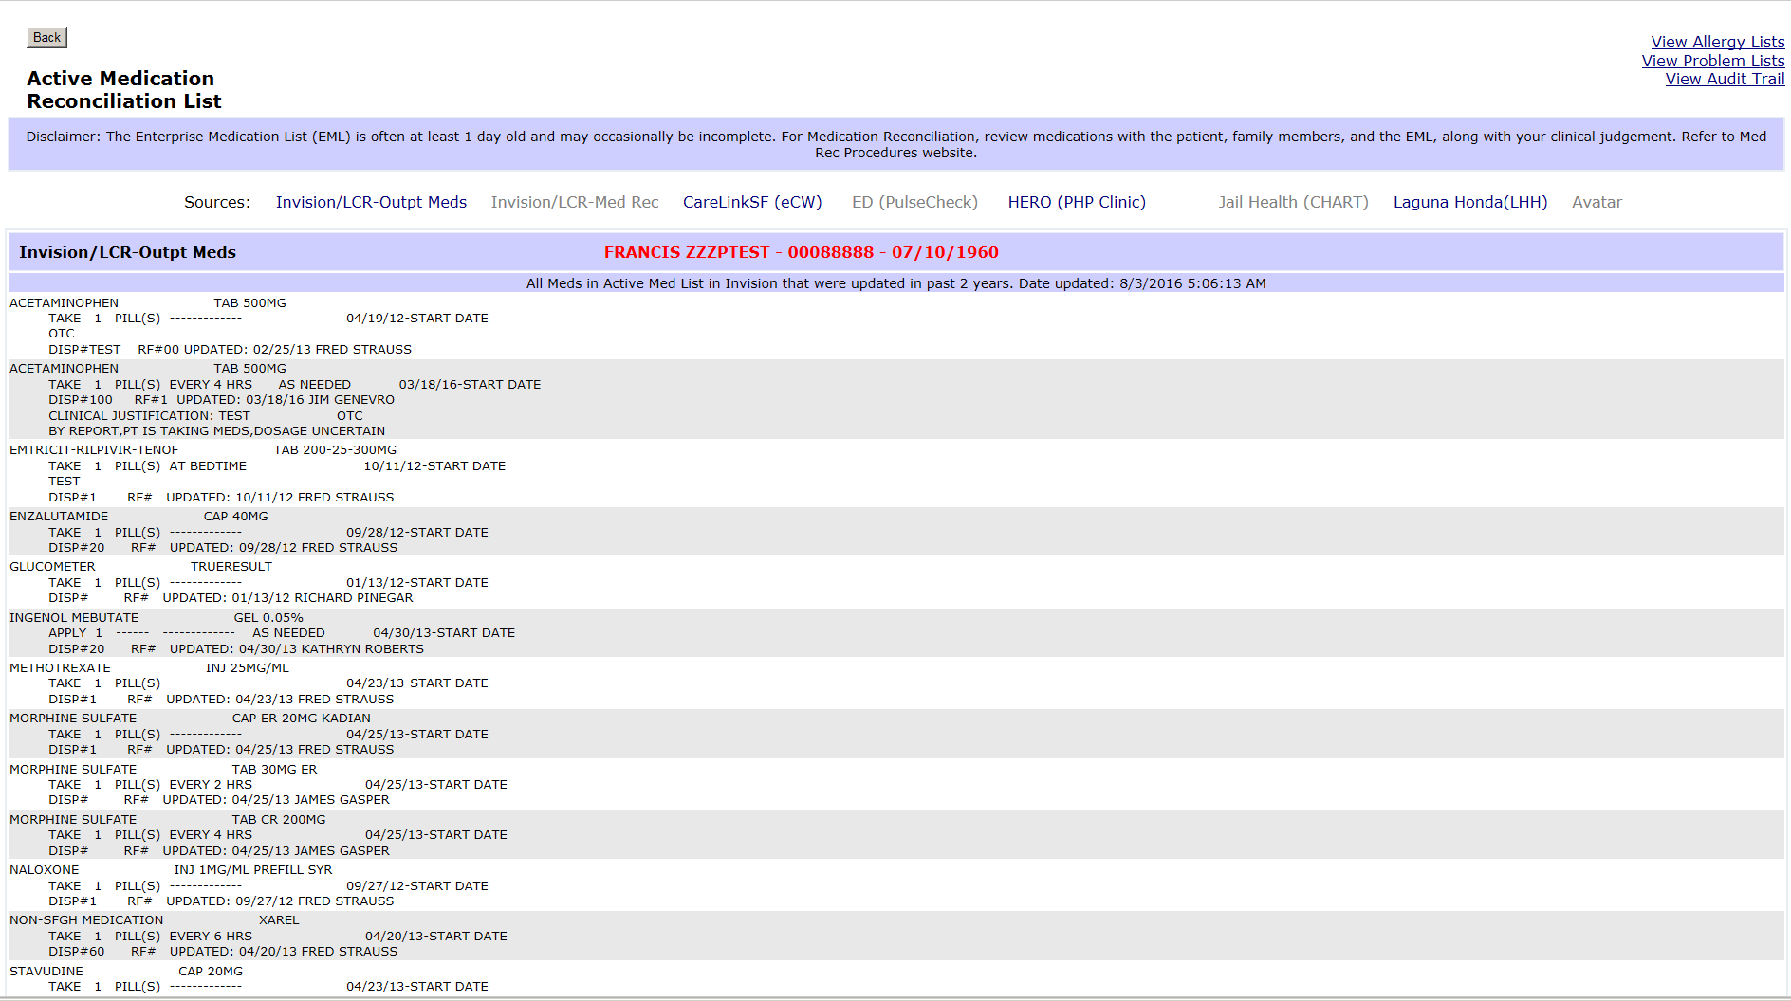
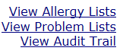
***Med list is not always up to date. Always review medications list with patient, family members, EML (enterprise med list). primarily used by Inpt Services.
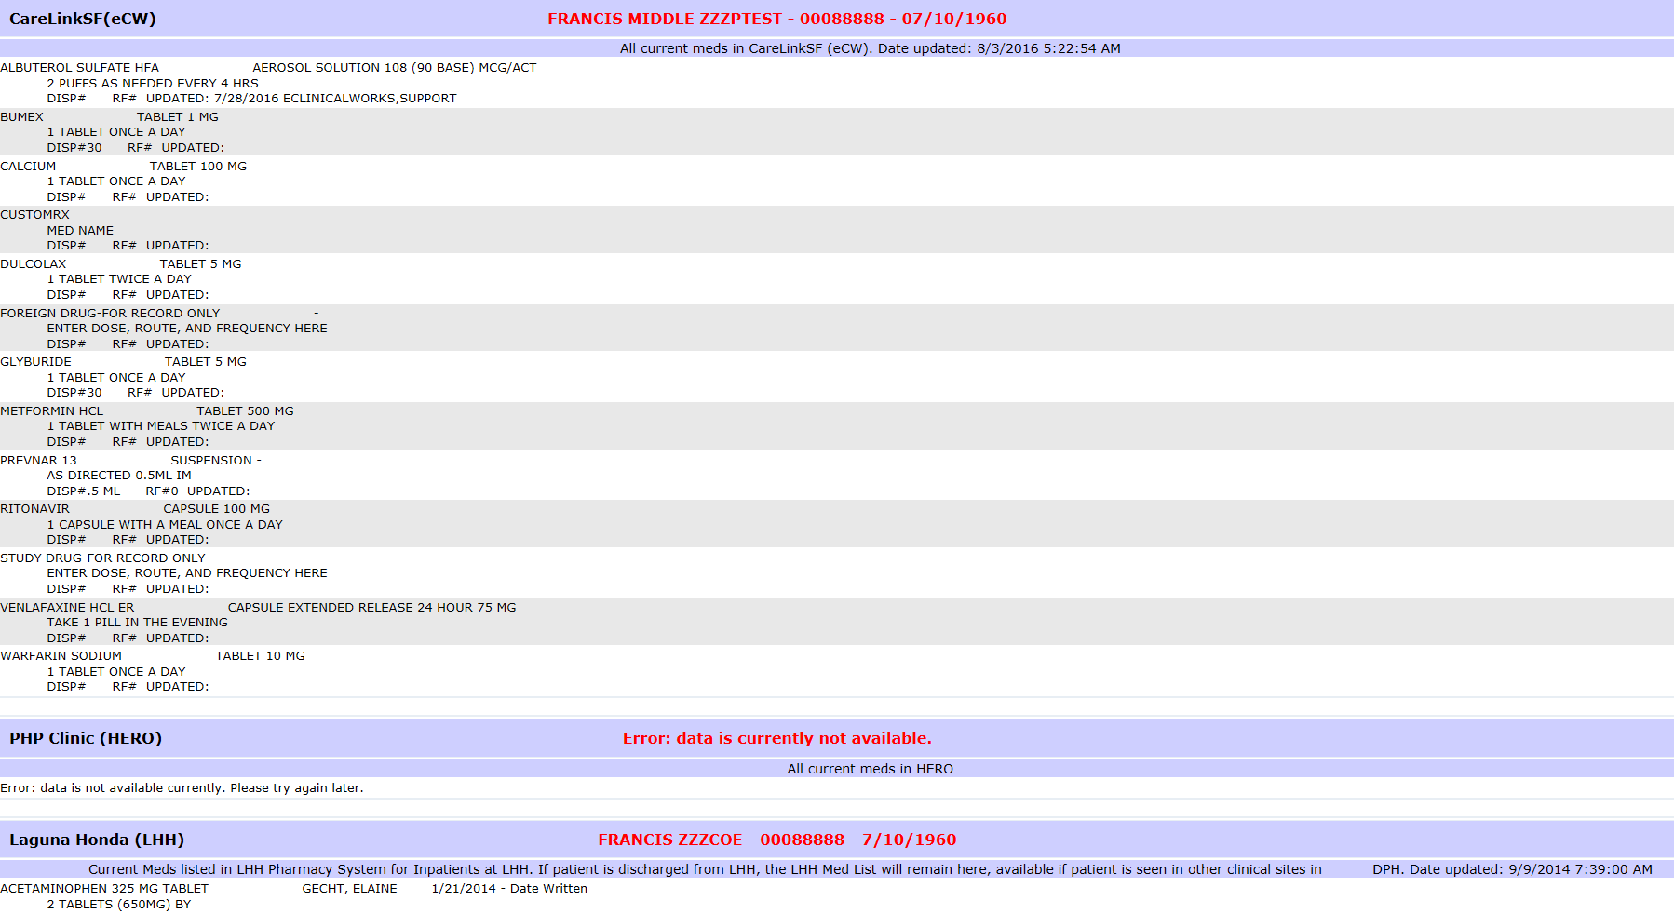
Enterprise med list pulls medication information from several different platforms such as Invision/LCR-output meds, Invision/LCR- Med Rec, CareLinkSF (eCW), ED (pulsecheck), HERO (PHP) Clinic, Jail Health (CHART), LHH, Avatar.
***List is always a day old and may occasionally be incomplete. For medication reconciliation- review medication list with patient, family members, EML. (Accuracy is dependent on provider updating data).
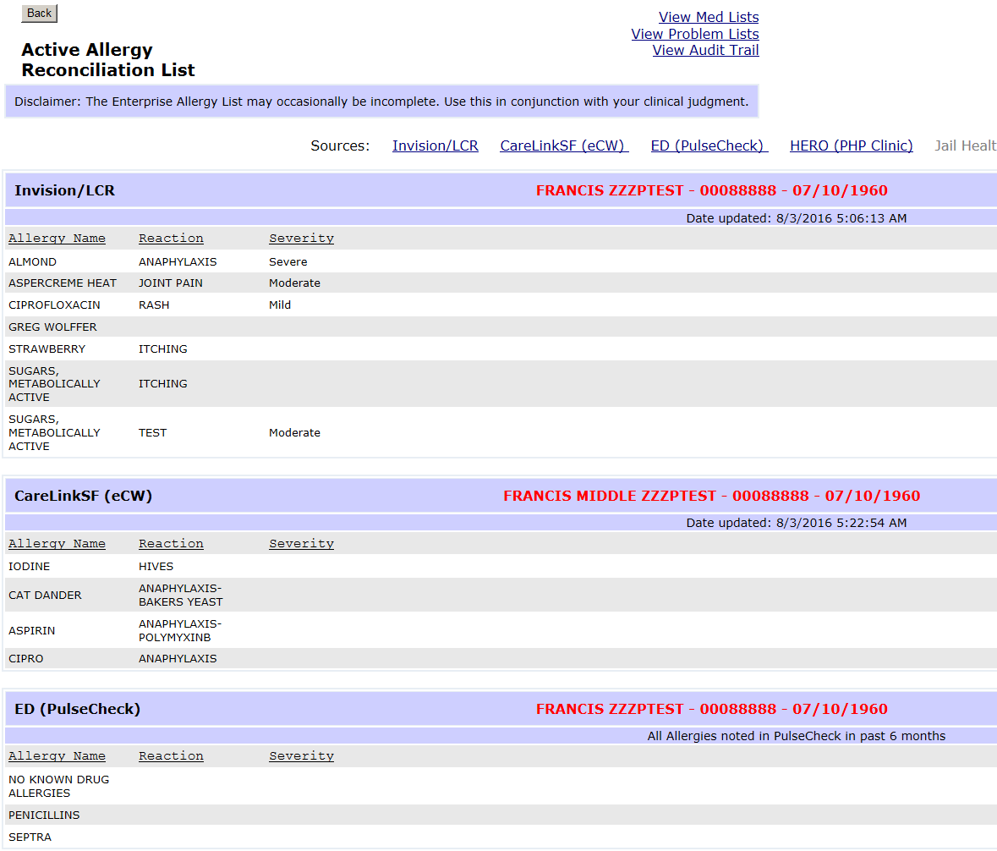
Allergy list are pulled from all platforms.
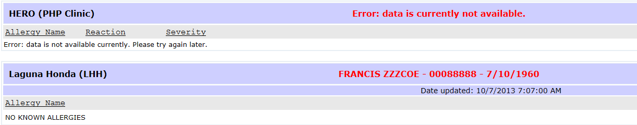

CCMS under e-Links
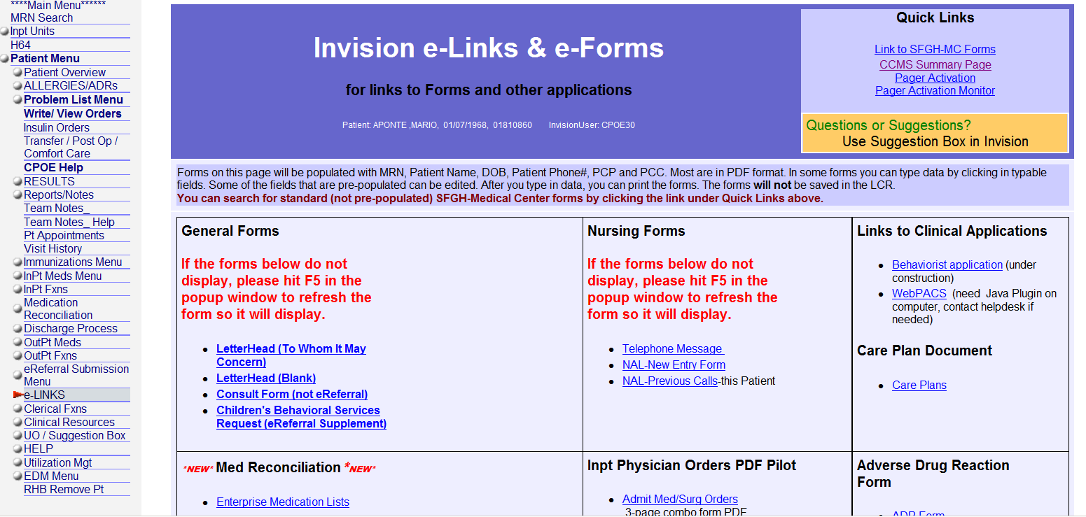
Access Patient’s CCMS (Coordinated Care Management System) Patient summary via eLINKS then CCMS summary page. Defaults to home page but can navigate by using Go to: Care Coordination for Behavioral Health, Respite and Sobering Center. For patients that meet certain criteria (vulnerable population, high utilizer accessing urgent/emergent services.

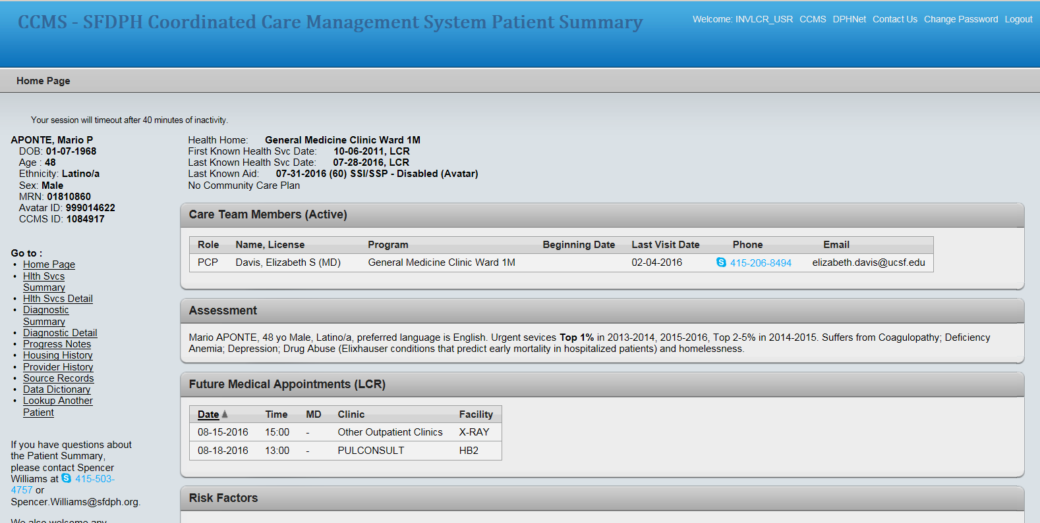

Panel management
PCP panel assignment management
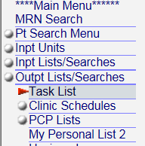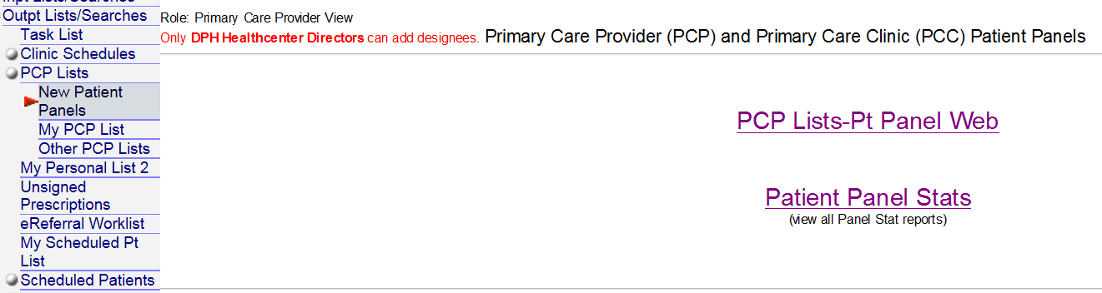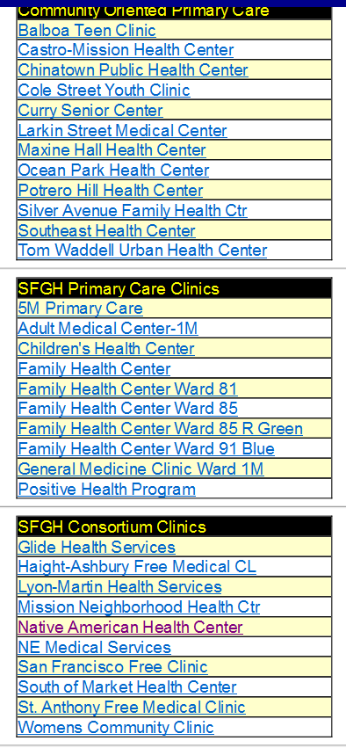
New Patient Panels: Lists Clinics by Type, Providers per Clinic and Patients per Provider

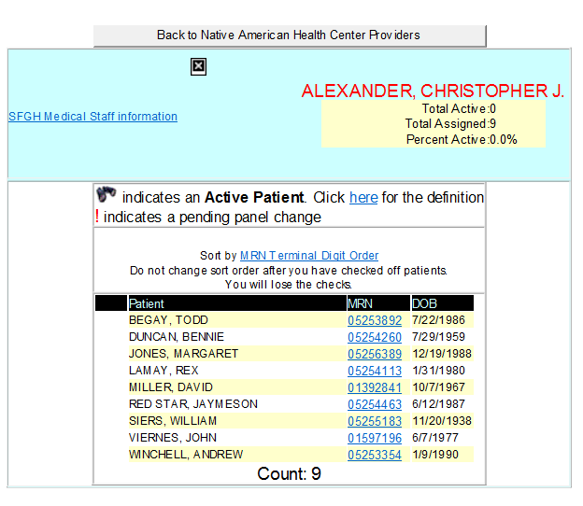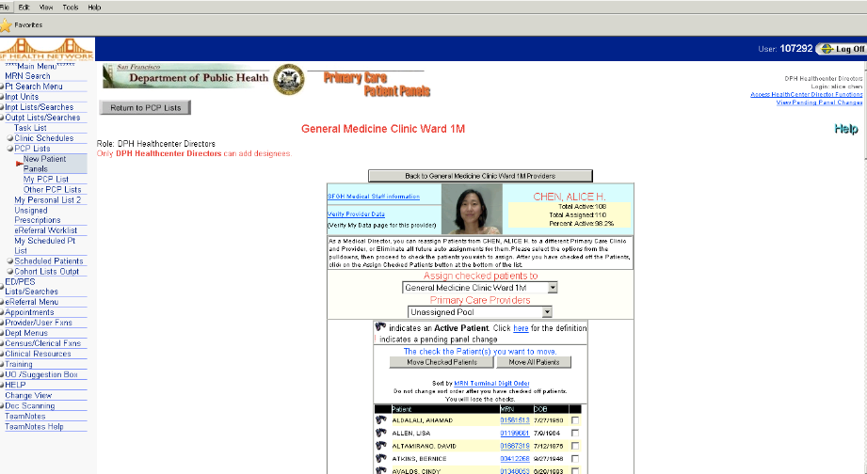
Medical Director can reassign patient’s to Provider individually or as group.
*** Request: Clinics to keep Provider list updated. Please email us if we need to update role as Medical Director. Alice.Chen@sfdph.org or Joan.Tadeja@sfdph.org

Instructions for Accessing LCR Discharge Worklist
1. From the home screen of the LCR, click on Dept Menus on the left.
2. Then click on Operations. This will result in the screen below. Next, click on “Care Transitions Discharge Worklist”.
3. This will generate an unfiltered list of all patients discharged from SFGH within the last 45 days. To filter, click on “Advanced search” in the top left corner.
4. Using the advanced search feature, you can filter the results based on a specific primary care clinic, (e.g., Curry Senior Center).

5. Scroll to the bottom and click “search.” This will generate a filtered list based on the criteria you entered. You can export these results into Excel or another format by clicking “Export results” at the top of the page. You can also print a specific page, or all pages.
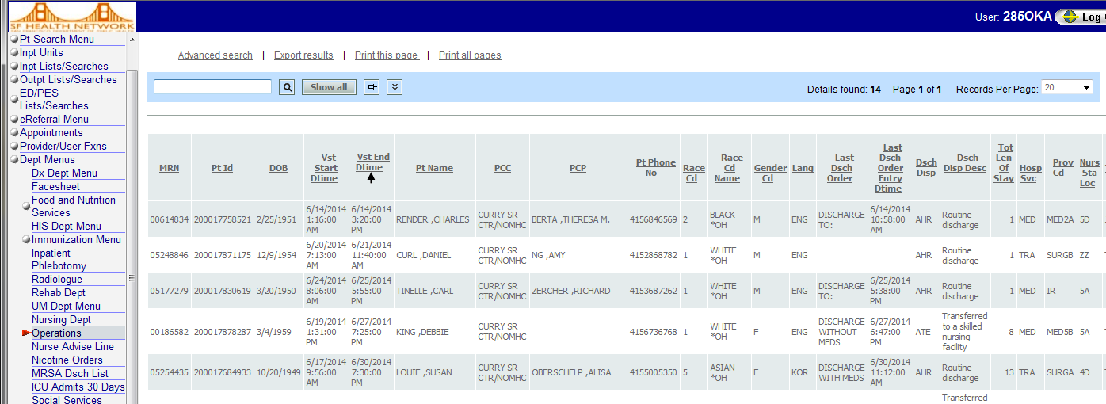
6. Some tips about the work list:
- Updates every morning, but there is a 24-hr delay.
- Admit Date = Vst Start Dtime
- Discharge date = Vst End Dtime
- You can also filter for discharge date by selecting an option from the drop-down box under advanced search and then entering the date you want. For example, if you wanted all patients discharged since July 23, you would select “more than” from the drop-down box, then type 2014-07-23 into the text box. “More than” includes the date you enter.
- Bed # = bed def
- # of 30-day readmissions to SFGH Med/Surg = MedSurg Accts30Days
- Date of last readmission to SFGH Med/Surg = Last Med Surg Dsch (same format for readmissions to SNF, PSY, & urgent care)
- Under the advanced search feature, only check the boxes to the left (under “NOT” column) if you want to exclude something. For example, if you wanted to exclude patients from the trauma service, you would check the box and then enter “TRA” into Hosp Svc.

Post discharge List Serve:
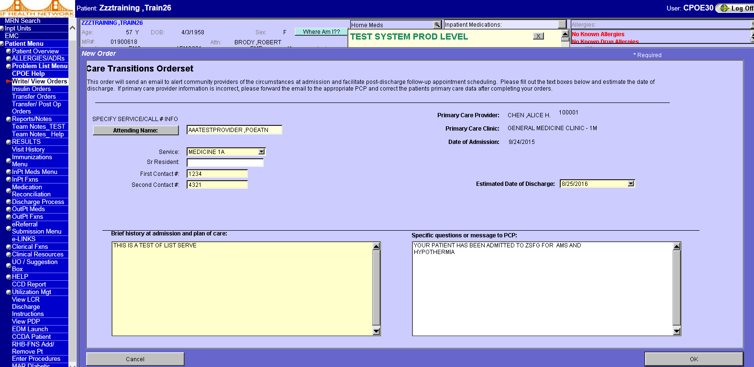
Admitting team: will complete Care Transitions Orderset.
PCP and PCH team: will receive an email notification regarding patients admission to the hospital.
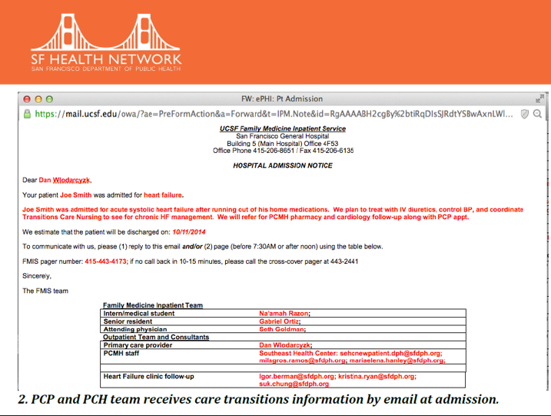

Other Email Notifications: Some LCR Reports,Dx Tests and Rehab referral available once you set up desired email notification list.
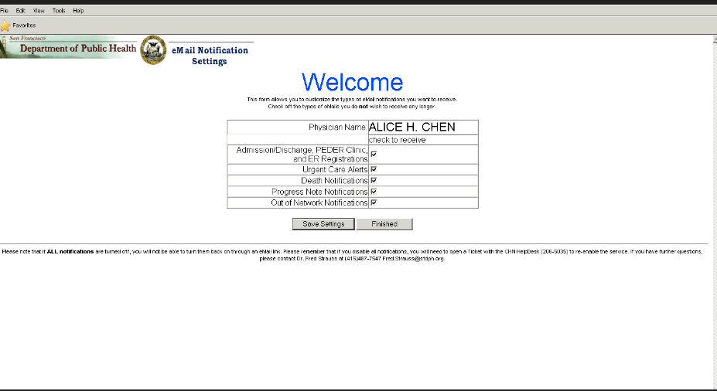
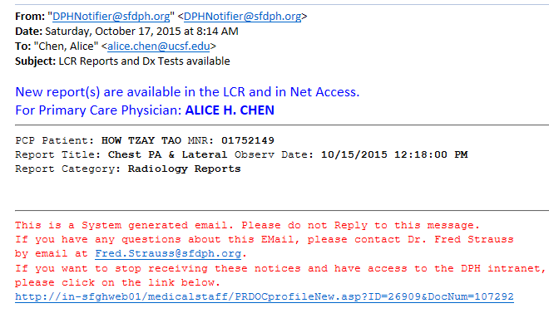
Providers are automatically enrolled for email notications when an LCR log in is created. Follow this link to customize email alets.

Getting Support:

User account creation or deletion, error messages and connetion troubles
SFCCC IT Support itsupport@sfccc.org or (415) 355-2254
Password changes or urgent issues
DPH Help Desk dph.helpdesk@sfdph.org or (415) 759-3577

